Step by step download coretax djp
- https://coretaxdjp.pajak.go.id/identityproviderportal/Account/Login
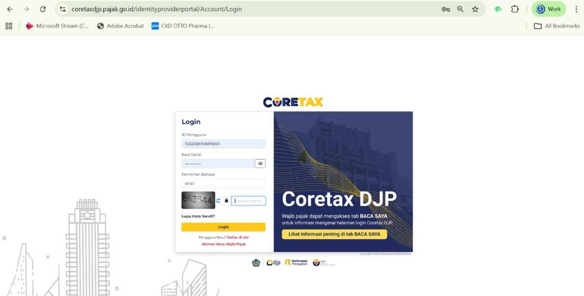

- https://coretaxdjp.pajak.go.id/registration-portal/id-ID/reg-home
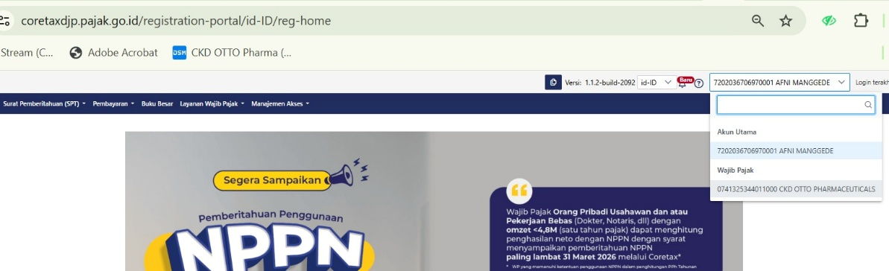
- https://coretaxdjp.pajak.go.id/registration-portal/id-ID/reg-home

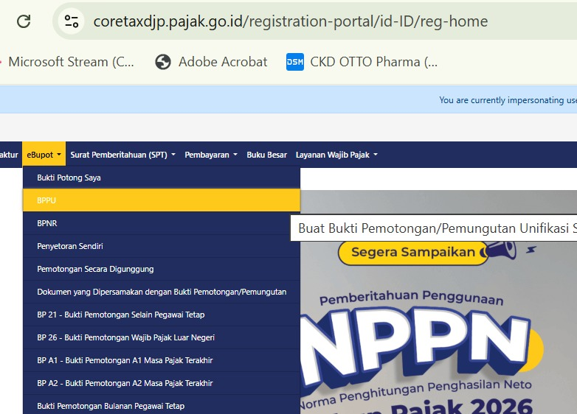
- https://coretaxdjp.pajak.go.id/withholding-slips-portal/id-ID/ebupotbpu/issued

